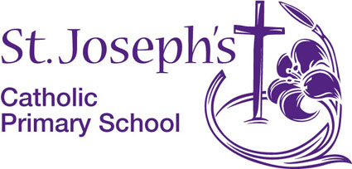
Woodford Lane
Winsford
Cheshire
CW7 2JS

Diocese of Shrewsbury in partnership
with Cheshire West and Chester Council

The Governors seek to appoint a 0.6 temporary KS2 Class Teacher from September 2026 (Grade MPS, not suitable for ECTs).

St. Joseph's is a thriving Catholic Community. We have happy children and a dedicated, friendly and supportive staff team. St. Joseph’s is a good school (Ofsted October 2018) which offers a good Catholic education for its pupils (Diocesan Inspection June 2022).

We are looking for an experienced KS2 teacher who has high expectations and has the gift of inspiring children in their learning. Candidates should be innovative and creative with the skills to plan, deliver, evaluate and asses a rich and varied curriculum which allows every child to fulfil their potential. We are seeking a teacher who is able to demonstrate a clear understanding of what constitutes outstanding teaching and learning along with the drive to maintain exemplary standards and progress. As a Catholic school, a commitment to our school values is essential.

The school is committed to safeguarding and promoting the welfare and safety of children. The successful candidates will be required to complete an enhanced DBS disclosure and will follow a stringent vetting and induction process.
Prospective candidates are warmly welcome to visit the school, please contact school to make an appointment.
Closing Date: 19th May 2026 (4pm)
Interviews: 22nd May 2026

Please note that applications must be submitted on the CES application form available from the school website. Further information is also available from our website www.stjosephs.cheshire.sch.uk.

Applications should be returned to
Mrs M. Gum, Headteacher,
head@stjosephs.cheshire.sch.uk

