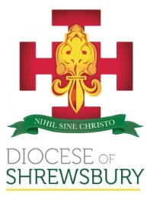
Diocese of Shrewsbury
Department of Education

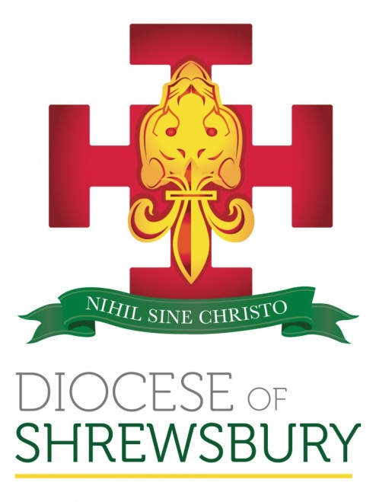

RE and CATHOLIC LIFE NEWSLETTER

Spring Term 2021 No.1

RE & CATHOLIC LIFE NEWSLETTER – SPRING 2021 No 1

Dear Colleague

- INTRODUCTION
Welcome back and a very happy new year to you all. We hope you have had a peaceful Christmas full of joy and that you and your families have stayed well over the festive season.
Although the shops will have removed all their Christmas decorations, and the Easter eggs will already be on some shop shelves, the Christmas season continues to be celebrated in the Church until the Feast of the Baptism of Our Lord, which will be celebrated on Sunday 9th January. However, you could still be celebrating Christmas until 2nd February, the Feast of the Presentation of the Lord. The Vatican keeps their tree and nativity scene up until that date!
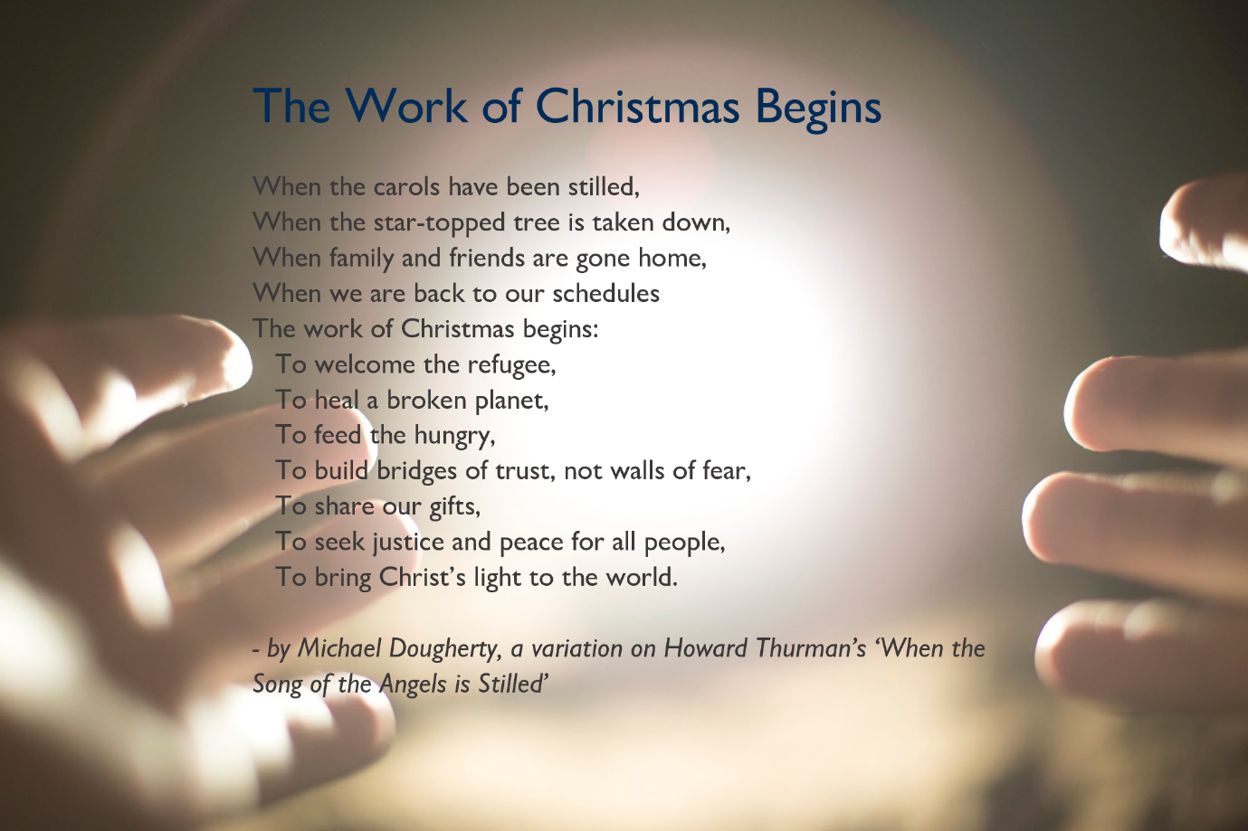
Whenever the decorations and tree have come down though, we know that the work of Christmas continues, as this short reflection shows us.
We begin the year on a sad note. Dominique Davies, RE Coordinator and Deputy Head at St Paul’s in Poynton suddenly passed away on 27th December after a short illness. Many of you will know Dominique from her contribution to Religious Education in our Primary schools and numerous Diocesan events. Please pray for the repose of her soul and keep in your prayers Dominique’s family, friends, and the community of St Paul’s, Poynton.
Eternal rest grant unto her, O Lord
And let the perpetual light shine upon her.
May she rest in peace.
Amen

- CPDF FOR THE SPRING TERM
In light of the current situation, and in conversation with representatives of DASH and DAPH, we have had to make some changes to the published CPDF schedule, with many of the planned ‘in person’ sessions now being offered virtually. Please see below the updated schedule for this term and take note of the new timings:
RE and Catholic life: a course for primary practitioners: this course has been postponed as it will not easily be transferrable to an online session. Delegates who have already signed up have been informed.
We hope to begin the course in the summer term but will review this after half term.
Prayer and Liturgy Twilight Sessions: Unfortunately, it will be necessary to postpone the next planned session (currently scheduled for 12th January). A delay to the release of the draft Prayer and Liturgy Directory has meant we have had to review the published dates.
Session One will now be a virtual session on Tuesday 8th February 4.00pm-5.30pm
Session Two will go ahead on 17th March as planned, though as a virtual event only.
Induction session for new RE Coordinators (Thursday 20th January): this was scheduled to be a face-to-face meeting; however, this will now be a virtual session and an opportunity for staff new to the role of RE Coordinator since October to meet with other new RE Coordinators and find out more about this important role. The session will be slightly shorter and run from 1.30pm-3.30pm.
COAST: this was scheduled for 19th January at Loreto Grammar School in Altrincham. This meeting will now be online on 19th January 9:30am – 12.00pm
School support for inspection under the new CSI (Catholic Schools Inspectorate) framework scheduled for Friday 28th January: this will continue to be a face-to-face session to support schools who will be inspected under the new framework, especially those due to be inspected in 2022-23.
The RE Coordinator hub meetings will now run as half day virtual meetings:
Shropshire, Telford and Wrekin Hub 7th March, 9.30-12.00
Cheshire West and Chester Hub 9th March, 9.30-12.00
Cheshire East Hub 10th March, 9.30-12.00
Wirral Hub 18th March, 9.30-12.00
Runcorn and Warrington Hub 21st March, 9.30-12.00
Stockport and Tameside Hub 22nd March, 9.30-12.00
Manchester and Trafford Hub 23rd March, 9.30-12.00
Secondary DADAH and Secondary RSE Leads meetings were already scheduled to be virtual.
The SHORE meeting on 30th March will hopefully still run as a face-to-face meeting at St John Henry Newman Parish Centre in Latchford. This will be reviewed at half term.
To book onto any of the above courses please click on the link below:
https://www.dioceseofshrewsbury.org/education/courses/book-a-cpdf-course
NB: the virtual drop-ins will continue as scheduled.
RE Coordinators 26th January, 3.30-5.00
SHORE 27th January, 3.30-5.00
If you have any queries or questions regarding RE, assessment or any of the national developments you can log on at the above times to discuss them, though feel free to contact me via email or phone at any point: julia.cunningham@dioceseofshrewsbury.org Mob: 07715 521 902

The revised Calendar for all CPDF courses this term can be found by following the link below:
CPDF Calendar - Spring 2022

- CATHOLIC SCHOOLS INSPECTORATE
The new national framework for inspections of Catholic schools requires all inspectors to become members of the Catholic Schools Inspectorate (CSI).
Eligibility criteria to become an inspector includes:
- be a practising Catholic​
- be a qualified teacher
- either be one of the following in a school judged to be good or better under both statutory and denominational inspections:​
  - a current or recent holder of one of the three posts defined as a reserved post in the Bishops’ memorandum
  - a current assistant head teacher
- or be one of the following:
  - a current or recent holder of a relevant and equivalent high-level leadership or advisory position within education;
  - in exceptional circumstances, an experienced Catholic Schools inspector (or an inspector of an equivalent predecessor diocesan inspectorate) who has attended all mandatory training and has continued to be actively involved in Catholic education

If you are interested in finding out more about the role and how to apply to become an inspector, we are holding a briefing on Wednesday 19th January 10.00-12.00.
To indicate your interest and receive the Zoom link to join the briefing, please click on the link below:
Register interest for the Catholic Schools Inspectorate

- DI INSPECTIONS 2021-22
For those schools who are being inspected this year under the current framework, support is available on request from your school support officer in the first instance, and carol.morgan@dioceseofshrewsbury.org (Denominational Inspection Coordinator for Primary) and julia.cunningham@dioceseofshrewsbury.org (Denominational Inspector for Secondary).
NB: the recording of the briefing held in June 2021 is available upon request
http://www.dioceseofshrewsbury.org/education/recordings
- SYNOD: A time for listening
A two-year ‘synodal’ process is taking place in the Catholic Church from October 2021 that culminates in the final Synod Gathering of Bishops in Rome in October 2023. The overall theme is “For a Synodal Church: Communion, Participation, Mission”.
“Pope Francis and the Synod of Bishops have stated that the objective of the current Synod is to listen, as the entire People of God, to what the Holy Spirit is saying to the Church. We do so by listening together to the Word of God in Scripture and the living Tradition of the Church, and then by listening to one another, and especially to those at the margins, discerning the signs of the times. In fact, the whole Synodal Process aims at fostering a lived experience of discernment, participation, and co-responsibility, where a diversity of gifts is brought together for the Church’s mission in the world.
The Synodal Process is first and foremost a spiritual process. It is not a mechanical data-gathering exercise or a series of meetings and debates. Synodal listening is oriented towards discernment. It requires us to learn and exercise the art of personal and communal discernment. We listen to each other, to our faith tradition, and to the signs of the times in order to discern what God is saying to all of us. Pope Francis characterizes the two interrelated goals of this process of listening: “to listen to God, so that with him we may hear the cry of his people; to listen to his people until we are in harmony with the will to which God calls us.”
This kind of discernment is not only a one-time exercise, but ultimately a way of life, grounded in Christ, following the lead of the Holy Spirit, living for the greater glory of God. Communal discernment helps to build flourishing and resilient communities for the mission of the Church today. Discernment is a grace from God, but it requires our human involvement in simple ways: praying, reflecting, paying attention to one’s inner disposition, listening and talking to one another in an authentic, meaningful, and welcoming way.
The Church offers us several keys to spiritual discernment. In a spiritual sense, discernment is the art of interpreting in what direction the desires of the heart lead us, without letting ourselves be seduced by what leads us to where we never wanted to go. Discernment involves reflection and engages both the heart and head in making decisions in our concrete lives to seek and find the will of God.
If listening is the method of the Synodal Process, and discerning is the aim, then participation is the path. Fostering participation leads us out of ourselves to involve others who hold different views than we do. Listening to those who have the same views as we do bears no fruit. Dialogue involves coming together across diverse opinions. Indeed, God often speaks through the voices of those that we can easily exclude, cast aside, or discount. We must make a special effort to listen to those we may be tempted to see as unimportant and those who force us to consider new points of view that may change our way of thinking.”
For a Synodal Church: Communion, Participation, and Mission Vademecum for the Synod on Synodality, 07.09.2021
How can you and your school communities be a part of the listening in this Synodal Process?
You can find out more about the Synod at:
http://www.dioceseofshrewsbury.org/news/latest-news/synod/
https://www.cbcew.org.uk/approaches-to-the-synodal-pathway/
https://press.vatican.va/content/salastampa/it/bollettino/pubblico/2021/09/07/0541/01166.html
- THE GOD WHO SPEAKS
The Bishops’ Conference of England & Wales agreed to continue with the Bible Society’s God who Speaks initiative at their last Plenary meeting. The Bible Society has deleted all references to the ‘Year of the Word’ as this phrase is now defunct, but they are still producing some excellent resources under the heading, God who Speaks:
Their January Focus is on Bible Resolutions: godwhospeaks.uk/new-years-bible-resolutions
23rd January is Sunday of the Word of God, a Day of Special Prayer for Openness to the Word of God. Resources for this day can be found here: godwhospeaks.uk/sunday-of-the-word-of-god
Canon Pat Hartnett looks at Life to the Full: Active Participation in the Liturgy - godwhospeaks.uk/life-to-the-full-active-participation-in-the-liturgy
They have created handy charts of Bible phrases in the Mass - godwhospeaks.uk/new-years-bible-resolutions/bible-phrases-in-the-mass
You can take a dazzling look at the book of Revelation in Clothed in White Robes by Fr Michael Hall - godwhospeaks.uk/clothed-in-white-robes
They have collated all of their Women in Scripture Art reflections here: godwhospeaks.uk/art-and-culture/women-in-scripture
- THE GOOD NEWS BIBLE – FAMILY EDITION
In partnership with Youth for Christ and others, Bible Society has created a brand-new Bible designed for families. Bible Society says, “It’s the GNB translation but it’s packed with interesting and informative extra features to help you engage more as you read through it. THINK. CHAT. DO. CREATE. WATCH.
The Good News Bible – Family Edition has been designed to encourage families to respond creatively to the text and contains plenty of interactions that will suit every member of the family. The additional content you’ll find inside will support you all as you discover the answers together.”
You can watch a short video about this edition and explore the extra features by following this link: Good News Bible – Family Edition - Shop - Bible Society. This may be something you want to share with your wider communities as a way to come closer to God.
NB: this isn’t an edition that has been approved for liturgical use. Approved texts would still need to be used.
- MA IN CATHOLIC LEADERSHIP
St Mary’s University, Twickenham, offer an MA in Catholic Schools Leadership. This Masters degree is offered to Primary and Secondary practitioners. Access the flyer here: http://www.dioceseofshrewsbury.org/wp-content/uploads/2022/01/St-Marys-PG_MA-in-Catholic-School-Leadership_A5-flyer.pdf

- ATCRE
Videos of the Keynote speakers and all the seminars from the conference in October can now be accessed on the ATCRE website: https://www.atcre.co.uk/conference-october-2021
- FARMINGTON SCHOLARSHIPS
Applications for the 2022/23 Farmington Scholarships are now open. These are Scholarships available to teachers of religious education and associated subjects in UK secondary, primary, and special needs schools. Head teachers who wish to undertake research into either religious education or values education are also eligible to apply.
Scholarships cover the cost of tuition, essential local travel and, by negotiation with the school, the salary of a replacement teacher up to point 6 of the main pay scale. Scholarships last for a maximum of 30 days and can either be taken at a local university (the institute have links with 13 throughout England, Scotland, Wales and Northern Ireland) or can be home-based with a local tutor. Further information and an application form can be found on their website
http://www.farmington.ac.uk/index.php/farmington-scholarships/
- THE FARMINGTON INSTITUTE PROJECT OPPORTUNITY
The Farmington Institute is partnering with Prof. David Clough to develop educational resources based on his Christian Ethics of Farmed Animal Welfare project. The project is looking for RE teachers at Primary or Secondary level to join a one-year project developing educational resources related to the project findings for use in schools. Teachers will meet monthly online with the Research Team, attend an in-person residential including a farm visit, receive funding for two days supply cover, and have the opportunity to apply for a Farmington scholarship extending this cover to 30 days. There is also the opportunity to gain MA module credit for work on the project. The deadline for expressions of interest is 30th January. Find out more here.
- RE: ONLINE – Research of the Month
RE:Online share monthly summaries of high-quality academic research that are relevant to classroom practice. Their research of the month feature aims to refresh and develop your professional knowledge and to help you get up to date with what others are doing. Each month a new piece of research or one chosen from their library is highlighted on their website.
For archive research and to access this month’s research, click here:
REOnline Research-of-the-month Archive

PRIMARY
- THE WAY, THE TRUTH AND THE LIFE
There have been several queries regarding the order of topics on the Leeds WTL website. Leeds Diocese have made changes to their sacramental programme and the age at which pupils receive the Sacrament of Reconciliation and the Sacrament of Holy Communion. As a result, they have altered the order of topics for some year groups.
If you are a regular user of the Leeds website, please be mindful of this and continue to follow the topic order in the WTL teacher and pupil books.
- MISSION TOGETHER CONSULTANCY BOARD
Mission Together regularly provide resources for schools and this year they plan to continue providing good quality, theologically sound, and accessible resources for schools.
To help with this, they wish to create a Mission Together Consultancy Board, made up of practising RE Coordinators. Membership wouldn’t be onerous; just three online meetings a year, no longer than 90 mins. If you are interested in joining this initiative you can view the Terms of Reference for more information
Mission Together are also hoping to recruit some freelance Mission Together resource writers in 2022. If you know of any recently retired RE Coordinators who may be interested or you are a part time RE Coordinator and are interested, please see the job advertisement Educational Materials Developer (Primary) job advert

SECONDARY
- SUMMER SERIES2022
I am sure you have already seen this document from JCQ outlining their expectations that assessment centres publish advanced information guidance on specific areas of content the examinations will focus on. If you haven’t yet seen it you can access it here
EDEXCEL GCSE and A LEVEL
The Advance Information Guidance was discussed at a meeting just before Christmas. For those who were unable to attend, the information can be accessed via the links below. As per Ofqual letter to schools the guidance has been produced so that schools are familiar with the approach for the specifications they teach and is scene-setting information. These are outlines prior to full publication of the actual materials in the new year, which will be no later than the 7th February.
GCSE Religious Studies A
GCSE Religious Studies B
GCE (AS and A-Level) Religious Studies
Edexcel has promised to provide further training and support for ResultsPlus and ExamWizard next term, but the walkthrough of each is included in the slides from the meeting, which can be accessed here
Please note, ExamWizard is currently just available for GCSE.
If you have any queries, comments or feedback please contact Edexcel at any time:
katie.mcknight@pearson.com / peter.hodges@pearson.com
If you would like to access a recording of the meeting, please email
julia.cunningham@dioceseofshrewsbury.org
- COLUMBAN MISSIONARIES: SCHOOLS MEDIA COMPETITION
The Columbans have launched their 5th annual competition for young people on the theme: "Anyone Can Make A Difference: 21st Century Changemakers", based on a quote from climate campaigner Greta Thunberg who said "No-one is too small to make a difference". The deadline for entries is 11th February.
For more details visit https://www.columbancompetition.com/submit-image/britain and the flyer
RSE
- TEN:TEN Life to the Full
For those schools and colleges using Life to the Full from Ten:Ten for their RSE provision, a reminder they regularly update their resources for schools and have a dedicated Hub space on their website for users with the latest news.
In December, Ten:Ten published Protected Characteristics Guidance for schools to complement their resource materials.

And finally…
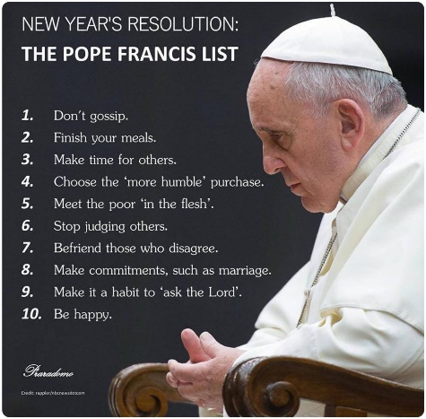
If you are wondering about what resolutions you can make for 2022, perhaps take some inspiration from Pope Francis. A post on Rappler in 2014 by Paterno Esmaquel II is a lovely overview of Pope Francis' primary concerns. “He preaches against gossip, reminds us to finish our meals, and even tells us not to fear marriage. Described as the “world's parish priest,” Pope Francis goes beyond abstract theology, and gives us advice we can use daily.”
Rappler compiled 10 of the Pope's most memorable quotes in the form of New Year's resolutions. You can find the full text here

God bless, Julia and Cath

