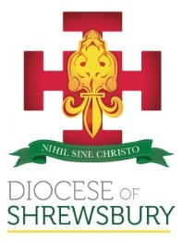
Diocese of Shrewsbury
Department of Education

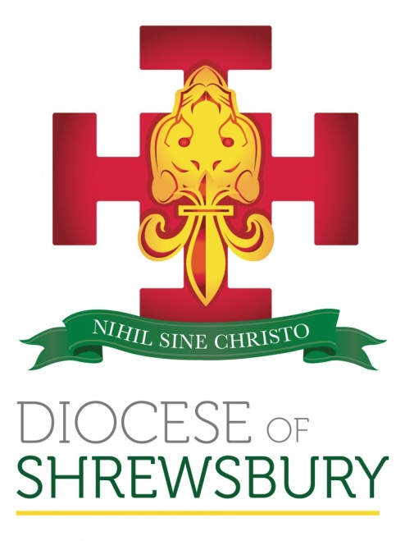

NEWSLETTER

Autumn Term 2020 No.3

DEPARTMENT FOR EDUCATION NEWSLETTER – AUTUMN 2020 No 3

Dear Colleagues
- INTRODUCTION
This edition of the newsletter is an addition to our normal pattern of newsletter, but I did not want the term to finish without having the opportunity to bring you up to date on Diocesan information, but more importantly to thank all associated with our schools, particularly Headteachers, for the magnificent work that is being undertaken by you all in order to ensure Catholic education continues to grow and develop in these most demanding of times.
- CHANGES OF HEADTEACHER
St Martin’s Runcorn
Phil Hallman retires as Headteacher at the end of term and we thank him for his years of service to the Diocese and wish him health and happiness in his retirement. A special thank you to Phil who delayed his retirement until Governors were able to appoint his successor.
Catherine Ming takes over as Headteacher in January and we wish her every success in her new post.
St Joseph’s Stockport
Anne Hamilton finishes as Headteacher at the end of term and we thank her for her years of service to the Diocese and wish her health and happiness in her future endeavours in other educational fields.
Claire Spinks takes over as Interim Headteacher this week and we thank her for the support she is offering the school in this interim period.
Our Lady’s Warrington
Angela Emerton will leave her position as Headteacher at the end of term and we want to thank her for her service and commitment to the school. We wish her well for the future. Hayley Tyldesley has been appointed as Acting Headteacher and we thank Hayley and the governors of St Gregory’s for supporting the school in this interim period.
We continue to remember all our Headteachers in our prayers as they face the challenges of leading our schools in these unprecedented times.
- OFSTED
I met with Jonathan Smart HMI last week and he confirmed what was announced last week in that the return to full inspections continues to be under review but will not begin until the Summer Term of 2021. He confirmed that Outstanding schools will be subject to inspection, starting with those schools who have not received an inspection for over ten years. The full detail on the inspection of previously graded Outstanding schools can be found by clicking the link below.
Lifting of exemption for outstanding schools
Jonathan has offered to do a briefing for Outstanding schools in the spring term and I will provide details once a date has been finalised.
Ofsted have now published the detail of the Section 8 inspections that will take place in the spring term, which will be section 8 inspections of schools that are in a category or judged to be Requires Improvement. Full details can be found by clicking the link below.
Inspections in the Spring Term 2021
Ofsted has also published this week how it will inspect the teaching of protected characteristics in schools. This document also highlights what Ofsted will expect to see in terms of the teaching of the revised RSE and Health Education programme, and how judgements will be impacted if schools have not implemented the policy by the start of the Summer Term. This was an intended focus for us as a Diocese following our discussions with Headteachers this term and we will be providing further support and information to schools in the new year. The link below provides the detail of Ofsted’s expectations.
Inspecting the teaching of protected characteristics in schools
- CPDF PROGRAMME
When we put together our programme of CPDF in the Summer term we had hoped to resume some face-to-face training. We have now made the following alterations to our proposed plan of training to enable them to be delivered virtually. The changes can be summarised as below:
SHORE Meetings: revised date for January session– now Tuesday 26th January 9.30 – 12.00; March session now virtual 9.30. – 12.00
NQT/RQT Sessions: 12 January - revised timings now 9.30 – 11.30 and 1.30 – 3.30, March session now virtual 9.30 – 3.30
DADAH - Catholic Life: Change of date now Monday 18th January
Primary DADAH: revised timings now 9.30 – 11.30 and 1.30 – 3.30
Induction for New Foundation Governors: All now virtual sessions with one session removed
COAST Meetings: All virtual session and revised timings 9.30 – 12.00. Revised date for March session – now Wednesday 10th March
New Headteacher Induction: No longer 2 day residential now virtual session Friday 22nd January 9.30 – 12.30 and possible residential 4th and 5th March
Headteacher Briefings: Now Virtual session
Governor Briefings: All virtual session and one less session
Foundations In Faith – Postponed until the Summer Term, new date Wednesday 5th May
Morning of Reflection for Headteachers and Chairs of Governors: Now virtual session 9.30 – 12.00
Primary DADAH: Now virtual sessions on 16 March, 9.30 – 11.30 and 1.30 – 3.30
R.E. Co-ordinator Meetings: change of date 23rd March 9.30. – 12.00; 24th March 1.00 – 3.30
The revised calendar for all events this term can be accessed by the following link
Revised CPDF Calendar Spring Term 2021
- CCRS
Please click link below to access the courses section of the diocesan website, where you will see an update from Fr Michael Coughlan on CCRS Sessions, Spring Term 2021:
http://www.dioceseofshrewsbury.org/education/courses/booking-course
- DENOMINATIONAL INSPECTION UPDATE
We have now received updated information from the DfE that there is an expectation that we should recommence Denominational Inspections in line with Ofsted Inspections. Therefore, it is now likely that we will recommence inspections in the Summer term of 2021 using the existing framework. We will not be taking part in the pilot of the National Framework in September 2021 but throughout the academic year of 2021-2022 we will continue to inspect under the existing framework. Those schools that should have been inspected in the Spring term of 2020 can expect to be inspected in the Summer Term of 2021. It may be that we can also do the schools that should have been inspected in the Summer term of 2020 in the Summer term of 2021, but there are potential capacity issues in trying to achieve this optimistic goal and so we will issue further guidance in the new year.
- RSE (RELATIONSHIPS AND SEX EDUCATION)
Following the Autumn Term meetings the Education Team have had with schools, where RSE has been very much on the agenda, we feel it is the right time to reinstate the RSE Working Parties to discuss the implementation of statutory RSE in the current climate and how we, as a Diocese, can further support schools. The working parties will be meeting early in the new year, so it would be helpful to have as full a picture as possible with regard to how our Diocesan schools are progressing. To that end, if you haven’t already done so, please do complete the short survey which can be found on our Questionnaires webpage:
http://www.dioceseofshrewsbury.org/education/questionnaires.
Please do take care to complete the survey relating to your phase. Many thanks to those schools who have completed the survey already.

I would like to conclude by thanking all those working in and associated with our schools for the unstinting service they have given to Catholic education in these unprecedented times. More than ever, we have come to realise that our work in education is a vocation and as with any vocation it has many great joys but also many challenges. I am sure that as we all have reflected on the increased demands on us in the pandemic, we have also felt the support of not only personal prayer but the collective power of prayer as we have continued to pray for one another.
I wish you and all your families a happy, healthy and restful Christmas and I am sure that we are all praying that the New Year will bring about changes that will enable a level of ‘normality’ to return to our lives.
God bless
Damian

