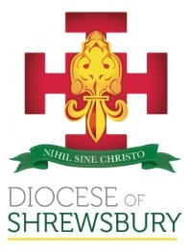
Diocese of Shrewsbury
Department of Education

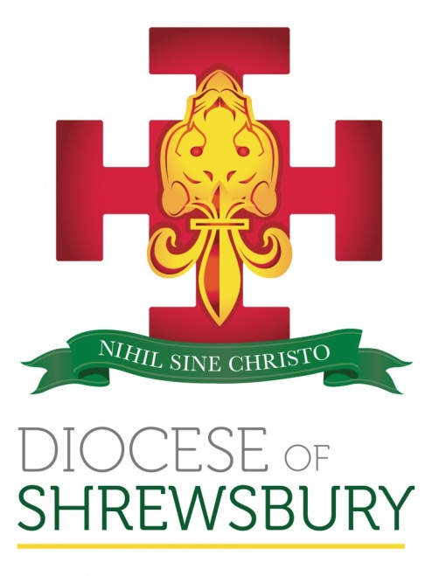

NEWSLETTER

Summer Term 2021 No. 2

DEPARTMENT FOR EDUCATION NEWSLETTER – SUMMER 2021 No 2

Dear Colleague

- INTRODUCTION
I hope you had a good mid-term break and are refreshed for the challenges of the new term.

- APPOINTMENT AND CHANGES OF HEADTEACHER
The following Headteachers will be leaving the service of the Diocese at the end of term:
Mr S Blain – St Mary’s, Congleton
Mr K Powell – St Saviour’s, Ellesmere Port
Mrs D Ormes – St Winefride’s, Neston
Mrs K O’Hare – St Edward’s, Runcorn
We thank them for their service to Catholic education in the Diocese and wish them health and happiness in all their future endeavours.

The following have been appointed as substantive headteachers:
Mrs N Ferguson – St Anne’s, Nantwich
Mrs A Snell – St Edward’s, Runcorn
Mr G Hawes – Executive Headteacher, Blessed Edmund Campion Federation
Mrs K Ryan – St Peter’s, Stalybridge
Mr J Marciniak – Our Lady’s, Warrington
We wish them every success in their new appointments.

The following temporary appointments have been made:
Mrs J Davies - St Winefride’s, Neston
Mr J Forber – St Chad’s Catholic and Church of England High School, Runcorn
Mrs C Spinks – St Joseph’s, Stockport
Mrs A Reeh – St Joseph’s, Sale
We are grateful to these colleagues for the support they are giving to our Diocesan schools on an interim basis.
We continue to remember all our Diocesan Headteachers in our prayers and thank God for their continued service and commitment to our Diocese.

- CPDF PROGRAMME
The following courses are being run over the next few weeks (all courses are virtual unless specified otherwise). All courses are bookable through the Diocesan website by following the link below:

http://www.dioceseofshrewsbury.org/education/courses/book-a-cpdf-course

RE Co-ordinator Hub Meetings:
17th June Stockport & Tameside (am), Cheshire East (pm)
21st June Wirral (am), Manchester & Trafford (pm)
28th June Cheshire West & Chester (am), Runcorn & Warrington (pm)
1st July Shropshire, Telford & Wrekin (am)

Governor Briefings:
22nd June Evening session
23rd June Afternoon session
24th June Evening session

14th June Primary Curriculum Working Party – Summer Term, Session 2
15th June NQT/RQT Induction – Summer Term
16th June COAST – Summer Term, Session 2
16th June DI Briefing
22nd June DI Workshop for Schools
23rd June SHORE – Summer Term
24th June New Headteacher Induction, Session 6 – Park Royal Hotel, Warrington
24th June Secondary RSE Leads
30th June Primary Deputy & Assistant Headteacher Forum (choice of am or pm session)

- GOVERNOR TRAINING DATES 2021/2022

On the basis of feedback that we have received from Governors, the programme of governor training will be virtual and details can be found below. We will be organising a Governors’ Conference which will be a face to face session held at Blessed Thomas Holford Catholic College, Altrincham on Saturday 6th November. The day will begin with Mass celebrated by Bishop Mark and with Eileen Mulgrew HMI as the keynote speaker.

New Governor Induction Training (Virtual Sessions):

Autumn Term 2021
Tuesday 21st September 6 – 7.30 pm
Thursday 23rd September 2 – 3.30 pm

Spring Term 2022
Tuesday 18th January 6 – 7.30 pm
Wednesday 19th January 2 – 3.30 pm

Summer Term 2022
Tuesday 3rd May 6 – 7.30 pm
Wednesday 4th May 2 – 3.30 pm

Future Governor Briefings (Virtual Sessions):

Autumn Term 2021
Tuesday 5th October 6 – 7.30 pm
Wednesday 6th October 2 – 3.30 pm
Thursday 7th October 6 – 7.30 pm

Spring Term 2022
Tuesday 1st February 6 – 7.30 pm
Wednesday 2nd February 2 – 3.30 pm
Thursday 3rd February 6 – 7.30 pm

Summer Term 2022
Tuesday 17th May 6 – 7.30 pm
Wednesday 18th May 2 – 3.30 pm
Thursday 19th May 6 – 7.30 pm

- DBS CLEARANCE FOR GOVERNORS
A reminder to all schools that all governors must have an enhanced DBS within 21 days of being appointed. As a school you should ensure that all Governors have a current DBS and we would recommend that the DBS is renewed every 4 years.

- CPDF PROVISION 2021-2022

In preparing our programme of training and formation for the next academic year we wanted to consider how we move forward with a blended approach of face-to-face sessions and virtual sessions. We drew together a focus group of both primary and secondary headteachers to consider what would be the best format moving forward. A summary of the outcomes of this work can be found by following the link below (password: education):

http://www.dioceseofshrewsbury.org/education/information-schools/newsletters

We would welcome any further feedback from Headteachers on these proposals, but as we are currently planning the delivery of this programme we would ask that this is sent to Sue Jenkinson no later than Monday 21st June.

- HEADTEACHER ABSENCE

The following information was shared with Governors at the last briefing in relation to managing Headteacher absence:

- If the Headteacher is absent from school then it is the responsibility of the Chair of Governors to notify both the Diocese and the LA.
- The Deputy Headteacher will be expected to deputise for a short term absence.
- If the absence is longer term (trigger will be in the school’s sickness absence policy) then the Governors will need to appoint an acting Head.
- The Deputy Headteacher does not have to take on the role of acting Headteacher and the Governors will have to liaise with the Diocese and the LA if an external appointment is going to be made.
- The same sickness absence protocols will need to be followed for the Headteacher as any other member of staff.

- NORTH WEST DIOCESES COURSES

Many of you will be aware from last term’s Headteacher briefing that the NWCDTP has designed a suite of new leadership courses, supported by ongoing opportunities for formation and development open to all colleagues in our schools. The full brochure was emailed to schools prior to half term but it can also be accessed by following the link below:

NW Diocese Training Partnership Brochure
- EARLY CAREER FRAMEWORK

We are still in discussion with ECF providers to see what opportunities there are for our current NQT/RQT programme to be incorporated into these frameworks, as well as looking at how we deliver the Foundations in Faith. It appears that whilst there may be some flexibility in allowing for the ECF to be influenced by the workings of a faith school, there will not be the opportunities to provide the level of depth that currently exists in our NQT/RQT programme and the Foundations In Faith programme. We therefore will be looking at what our offer will be to those new to Catholic schools and publish details in the near future.

As far as secondary schools are concerned, we hope that there will be an opportunity to deliver a standalone session on working in a Catholic school. As our discussions with the providers continue we will keep you updated.

- CCRS 2021-2022
We are currently aiming to deliver the CCRS course via two pathways next year. One being taught in person classes, the other a combination of online or virtual learning with in person seminars. The exact details will be determined in line with government guidelines as we progress through their roadmap.
CCRS is suitable for any teacher working in a Catholic school offering an in depth look at aspects of our faith even if you are not required to teach RE!
If you are interested please contact ccrs@dioceseofshrewsbury.org & we will keep you up to date as the plans are finalised!

- CARITAS SHREWSBURY

Can you help Caritas Shrewsbury?
Caritas have two new areas of work that they would love to involve teachers and school staff in:
- relaunching the Good Shepherd Appeal in Lent 2022. During 2021 could you help Caritas develop a schools pack to support fundraising for those most in need in our communities?
- piloting the use of teaching materials to deepen the understanding of Catholic Social Teaching (CST). Could you use your experience to give advice and support to CST focused work?
If you would like to find out more about either opportunity please email ben.gilchrist@caritasshrewsbury.org.uk
Thank you for all your support for Caritas and if we can support you in any other ways do get in touch.
- CES UPDATES

Mental Health and Wellbeing Packages
To mark Mental Health Awareness Week, the DfE has announced a mental health and wellbeing investment package to improve support in schools and colleges.
Funding will go towards training senior mental health leads, a new Wellbeing for Education Recovery programme and an adapted ‘Link' programme, designed to improve partnerships.
Further details are available in the press notice, which is available on GOV.UK. along with a comprehensive list of accessible and free mental health resources for all ages.
Recruiting teachers from overseas under the new immigration system
European Economic Area (EEA) and Swiss nationals who were living in the UK by 31 December 2020 – including teachers – can apply to the EU Settlement Scheme in order to continue living, working and studying in the UK. The deadline is 30 June 2021.
Overseas nationals arriving in the UK from 1 January 2021 come under the new points-based immigration system. Teachers arriving from this date, including those from the EEA and Switzerland, need to apply for a visa. Schools may need to become visa sponsors if they want to recruit teachers who are not UK or Irish nationals.
Find out more by reading guidance for schools about recruiting teachers from overseas
Updated Sickness Absence Policies
The updated sickness absence policies are available to download from the CES website. The policies can be accessed by following the link below:
https://www.catholiceducation.org.uk/employment-documents/model-policies-and-procedures
Separate versions of the policies are available for schools in England, schools in Wales and academies.
Schools should also ensure that they inform their HR provider of the existence of the new policies
In order to assist schools in understanding what changes have been made to the policies, please see below a link to access a document which outlines the changes we have made (password: education).
http://www.dioceseofshrewsbury.org/education/information-schools/newsletters
Although these policies have been consulted on at national level if schools are to adopt them they must engage in local consultation. We do not expect schools to make substantial changes to the policies without discussing this with the Diocese first, but they are able to make minor amendments to suit their own context and respond to their local consultation.
2021 School Admissions Code
You may be aware that the Department for Education has recently published the 2021 version of the School Admissions Code.
The 2021 version of the code remains subject to parliamentary approval which should be given in early July and we are also expecting some associated guidance from the Department for Education to be published at around the same time.
We will circulate more detailed information to schools once the official guidance has been published.

- OFSTED NEWS

Currently there is no published information on Ofsted’s plans for inspecting in the Autumn term. Eileen Mulgrew HMI will be speaking to the new Headteachers on June 24^{th,} and we will share any new information that is available at that time. Eileen has agreed to speak to all headteachers early in the Autumn term and will be the keynote speaker at our Governors’ conference on 6th November 2021.

I realise there are still many challenges for Headteachers in this next half term as you continue to plan for the new academic year with still a high level of uncertainty.

Best wishes
Damian

