
Diocese of Shrewsbury
Department of Education

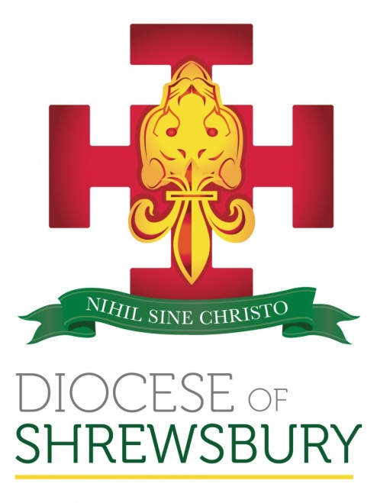

NEWSLETTER

Spring Term 2021 No.1

DEPARTMENT FOR EDUCATION NEWSLETTER – SPRING 2021 No 1

Dear Colleague

- INTRODUCTION

On Behalf of Bishop Mark and the Department Team may I wish the staff, governors and families of our Diocesan schools every good wish for 2021.

I realise that the start to the term has been very unsettling with the conflicting advice from central government and then the announcement on Monday night of the lockdown. The picture is still very unclear in relation to several key issues and as soon as we can provide Headteachers with any clarification we will do.

I would like to offer the opportunity to meet with Headteachers at the end of this week to assess what support and training would be useful this term. It is our intention to continue as planned but with all sessions being virtual. In order to take feedback from Headteachers on this proposal I will be holding a short virtual meeting for Primary Heads on Thursday afternoon at 2.00 p.m. and Secondary Heads on Friday at 11.30 a.m. To register please click the relevant link below

Primary Heads’ Meeting Thursday 7th January 2 p.m.
Secondary Heads’ Meeting Friday 8th January 11.30 a.m.

- APPOINTMENT AND CHANGES OF HEADTEACHER

There are no changes to those details provided in the Autumn Term No 3 newsletter issued at the end of last term.
- OFSTED

I was informed at the end of term that Jonathan Smart will no longer be our associated Ofsted link as he has been appointed Assistant Regional Director in the North West. Our new link is Eileen Mulgrew SHMI. Eileen is a former Diocesan Headteacher (St Monica’s, Warrington) and has worked with the Diocese before.

- ADMISSIONS POLICIES

Admissions Policy 2022-23
Thank you to all those schools who have already sent their finally determined Admissions Policy 2022-23 to us.
All Governing Bodies must determine and ratify their Policy by 28th February, and publish it on the school’s website by 15th March. Even if there have been no changes to your admissions policy can you send a copy to the Admissions email (admissions@dioceseofshrewsbury.org) and ensure that it is sent to the Diocese and the LA no later than 31st March 2021.
You will be aware that the Admissions Code of Practice has been revised and been out to consultation recently. As yet, the outcomes of the consultation have not been published. However, we have been assured by the CES that the Code states that once admission arrangements have been determined for a particular school year, they can be revised by the admission authority if such revision is necessary to give effect to a mandatory requirement of the Code. Therefore, Governing Bodies should continue with the process and not wait for the outcomes of the consultation.
In September we asked all schools to return details of their admissions for September 2020 for Reception and Year 7. Many thanks to all schools who have returned this information, but to date we still have 50 schools (over 40%) who have not returned the information. It is important that we are able to monitor admissions across the Diocese in order to look at future planning. I have created links to the returns (primary) and (secondary) and would be grateful if those schools who have not as yet been able to send us the information could do so as a matter of urgency to jake.murphy@dioceseofshrewsbury.org
- DENOMINATIONAL INSPECTIONS

I had indicated at the end of term that it is highly likely that we would recommence Denominational Inspections in the Summer term 2021 in line with Ofsted’s intentions to recommence the routine inspection of schools. It now seems likely that this will not be the case and so I will update schools as soon as we have more information.

- CPDF PROGRAMME

Please see the link below for full details of our revised programme for this term.

Revised CPDF Calendar Spring Term 2021

- UPDATES FROM CES
Employment checks for EU/EEA teachers from 1 January 2021.
The government has announced that 'from 1 January 2021 professional regulators in the EEA (EU, Iceland, Liechtenstein and Norway) will no longer share information about sanctions imposed on EEA teachers with the Teaching Regulation Agency (TRA)'. Previously, teachers who had lived or worked outside of the UK but within the EEA would have their information on regulatory sanctions shared by the relevant country with the TRA.

As this information sharing process will no longer continue, employers will need to conduct checks to ensure that applicants are not subject to regulatory sanctions outside of the UK. In practice, this means conducting checks in relation to those who have lived or worked in the EEA in a similar manner to the current checks required for those who have lived or worked outside of the EEA.
For applicants that have lived or worked outside of the UK, schools must make any further checks they think appropriate so that relevant events that occurred outside the UK can be considered (often called overseas checks), they also need to obtain an enhanced DBS certificate with barred list information (even if the teacher has never been to the UK) and letter(s) of professional standing (as described below). These checks should be conducted at the same time as the other pre-employment checks. Any offer of employment should be conditional on satisfying these checks in line with the advice contained in Keeping Children Safe in Education.

The employer (Governing Body or Academy Trust Company) should request from the applicant proof of their past conduct as a teacher. This proof should be a letter of professional standing issued by the professional regulating authority in the country in which they worked. The letter should include information on any regulatory sanctions the applicant has been subject to (where applicable). For every country in which the applicant has worked or lived (outside of the UK) a separate letter of professional standing should be obtained. Such evidence can be considered, by the employer, alongside information obtained through other pre-appointment checks to help assess the suitability of the candidate.
The announcement and relevant guidance is available at: https://www.gov.uk/guidance/changes-to-checks-for-eu-sanctions-on-eea-teachers-from-1-january-2021
Changes to application forms following DBS legislation changes
The government has recently introduced the Rehabilitation of Offenders Act 1974 (Exceptions) Order 1975 (Amendment) (England and Wales) Order 2020 (the “Order”).
This Order makes amendments to the DBS filtering regime in the following two respects:
- it has removed the requirement for the automatic disclosure of youth cautions, reprimands and warnings; and
- it has removed the ‘multiple conviction’ rule. A rule which meant that all convictions were automatically disclosed where a person had more than one conviction, regardless of the nature of their offence or sentence.
The Order applies to DBS certificates issued from 28 November 2020 onwards. Guidance has also been issued which can be accessed by following this link:
https://www.gov.uk/government/publications/dbs-filtering-guidance/dbs-filtering-guide
The CES has updated its model application forms and ‘Rehabilitation of Offenders Act – Disclosure Form’ in light of these legislative changes. We have included new model wording which is suggested in the government guidance cited above.
‘We have received a number of queries from schools in the past week about when changes will be made to the application forms and we would be grateful if you could inform schools that the updated versions of the model documents are now available on our website. Please also remind your schools to inform their HR providers that revised application forms are available.’
‘In response to feedback you will see that the application forms are now available in fully amendable word format. This will enable schools to make changes to the forms and you might want to make it clear in your communication that they should only be making substantive changes if they have your consent’
Specific guidance from the CES
- RELATIONSHIPS EDUCATION, RELATIONSHIPS AND SEX EDUCATION GUIDANCE (RSE) AND HEALTH EDUCATION

If you haven’t already done so, please do complete the short survey which can be found on our Questionnaires webpage http://www.dioceseofshrewsbury.org/education/questionnaires.

Please do take care to complete the survey relating to your phase.
Many thanks to those schools who have completed the survey already.

- FOUNDATIONS IN FAITH

Following the decision to hold all sessions in the Spring Term virtually, we have decided to postpone the final session for the 2019-2020 Cohort, as we did not feel colleagues would have the same experience if we attempted a virtual session. We are hopeful that face to face sessions may resume in the Summer Term so have tentatively booked the 5th May. Further details will be shared in due course.

- GOVERNOR APPOINTMENTS

As we start the new term can I remind schools and academies that although we welcome nominations for Foundation Governors from schools and Governing Bodies, it is the Bishop that makes the final decision and therefore potential Governors should not assume they have been made a Foundation Governor until they have received notification of their term of office in writing. Particular care needs to be taken if you are considering transferring a Governor from a previous status (e.g. Parent to a Foundation Governor). They must be formally appointed to the position of Foundation Governor.

Governors are reminded that in 2017, the Diocese placed a restriction on family members being Governors on the same Governing Body. If a Governing Body does have members of the same family, then this should be considered at the end of the Term of Office. This now appears in the Diocese’s List of Disqualification.
Governors’ Code of Conduct

All Governors should now have signed the CES code of conduct and this is a condition of being a Foundation Governor. During the course of the academic year we have had a number of matters to address which have been made more difficult as it appears that a number of Governors did not sign the code of conduct last year. We will be writing to all Chairs of Governors in the next week to ask them to confirm that all Governors have signed the code of conduct, and if not, what arrangements are in place for those who have not signed the code, to do so. It will now be an integral part of the governor recruitment process. It will also be something that Inspectors will look at in the revised Denominational Inspections (formerly Section 48).

I wish you and all your staff every blessing for the New Year.
Damian

