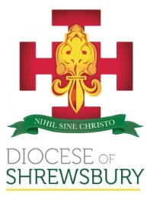
Diocese of Shrewsbury
Department of Education

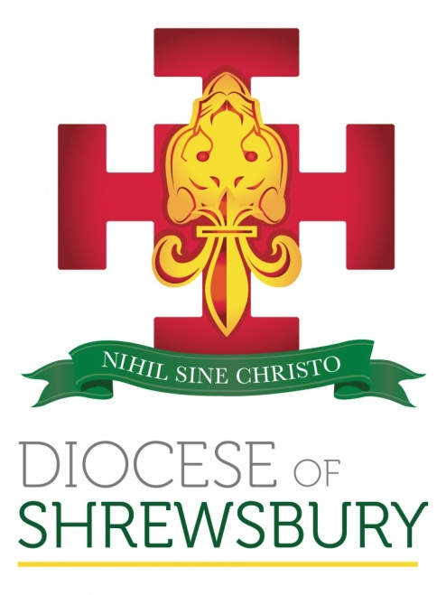

NEWSLETTER

Autumn Term 2021 No.2

DEPARTMENT FOR EDUCATION NEWSLETTER – AUTUMN 2021 No 2

Dear Colleagues
- INTRODUCTION
I hope all colleagues have had a restful half term and have managed to have some much-needed time with your families as we faced yet another unprecedented half term. I hope, that as we approach the season of Advent and Christmas, we are able to mark these significant events in the Church’s year in a more meaningful way than we were allowed to last year due to all the restrictions.
- CHANGES OF HEADTEACHER
St Mary’s Crewe
Sue Fau-Goodwin will retire as Headteacher at the end of term having served as Headteacher at St Anne’s Nantwich as well as St Mary’s Crewe. Sue also worked for the Department of Education on a secondment. We thank Sue for her service to Catholic education in our Diocese and wish her health and happiness in her retirement.
Catherine Wright will serve as Acting Headteacher in January, and we thank her for taking on this responsibility.
St Theresa’s Chester
Nickie Kirkman retires as Headteacher from St Theresa’s at the end of term. In addition to being Headteacher, Nickie has also served as a Denominational Inspector. We thank Nicky for her service to Catholic education in our Diocese and wish her health and happiness in her retirement.
Mark Cotton will leave his current position as Chief of Teaching and Development for the Holy Family Catholic Academy Trust at the end of term. For many years Mark served as Headteacher at Our Lady of Pity Catholic Primary School. We thank Mark for his service to Catholic education and wish him every success in future ventures.
The following appointments to headship have been made this term:
James Forber has been appointed substantive Headteacher of St Chad’s Runcorn with immediate effect.
Kevin Maddocks has been appointed substantive Headteacher of St Mary’s Catholic College, Wallasey with effect from 1st November 2021
Lisa Holland has been appointed as Headteacher at St Theresa’s Chester with effect from 1st January 2022.
We offer our newly appointed Headteachers every success in their new appointments and we continue to remember all our Headteachers in our prayers as they face the challenges of leading our schools in these unprecedented times.

- ADVENT LITURGICAL PRAYER

On 14th December, 4.00-5.00pm, we will hold ‘What must we do?’, our Diocesan Liturgical prayer for Advent at Our Lady and the Apostles in Shaw Heath. We are so blessed to have such gifted children and young people, and such supportive, committed staff in our Diocese happy to share their time and giftedness in the creation of this opportunity to gather in prayer and worship. As last year, the hour will be livestreamed from Our Lady and the Apostles and we would love our schools and colleges to contribute, whether reading, in song, or with their artistic talents. Please do get in touch with Julia Cunningham if you would like to be involved.

- OFSTED
None of our schools were inspected last term but we have shared with colleagues learning from inspections in other Dioceses. In addition, Julia Cunningham updated colleagues on a presentation given by Ofsted’s Lead on RSE & Health education. A recording is available for those unable to attend.
Ofsted have also done several Curriculum Roadshows and have released a number of recordings:
https://www.youtube.com/user/ofstednews

- CPDF PROGRAMME
Thank you to all schools that have supported our training programmes during last half term, and it appears that a mix of face-to-face session and virtual sessions is working well. We will review the delivery from January towards the end of term.
Please find below a full list of training events this half term, booking is via the Diocesan website:
http://www.dioceseofshrewsbury.org/education/courses/book-a-cpdf-course
01/11 R.E. Co-ordinators Meeting (Primary) – Autumn Term
03/11 Secondary DADAH – Catholic Life & Mission – Day 1
06/11 Governors’ Conference – Blessed Thomas Holford Catholic College
09/11 Secondary DADAH – Quality of Education – Day 1
09/11 COAST – Session 2 (Virtual)
10/11 North West Diocesan Hub – General R.E. (6th Form Colleges)
16/11 New Headteacher Induction – Session 3 (St. John Henry Newman Parish Centre & Virtual)
16/11 Secondary DADAH – Personal Development Behaviour & Attitudes – Day 1
16/11 Secondary RSE Leads - Autumn
17/11 North West Diocesan Hub – General R.E. (11 – 18 Schools)
23/11 SHORE Meeting – Autumn
30/11 Primary DADAH – Autumn 2 (Virtual)

- DENOMINATIONAL INSPECTION UPDATE
We have now completed the three pilot inspections and will continue to inspect this academic year as per the published schedule. Those schools not being inspected this year will receive a letter this week indicating the academic year when they will receive their next Denominational Inspection. This letter can be used to verify to Ofsted that an inspection has been planned.
- GOVERNORS
If you would like us to list any Foundation Governor vacancies on our website, could you please contact Jake Murphy on jake.murphy@dioceseofshrewsbury.org
We are actively looking for Foundation Governors for a number of schools across the Diocese. If you are aware of anyone who meets the criteria and would like to become a Foundation Governor, could you ask them to speak to their Parish Priest and the relevant school.
We would remind schools to complete the Governors’ Code of Conduct Analysis return it to Sue Blackwell on sue.blackwell@dioceseofshrewsbury.org (if you have not already done so).
- NORTH WEST CATHOLIC DIOCESES TRAINING PARTNERSHIP
I am very pleased to able to report that are schools are very well represented on the new leadership courses being organised by the North West Dioceses Training Partnership. Can I ask that Headteachers and Governors on making appointments give serious consideration to providing newly appointed colleagues with appropriate leadership training as when reviewing applications we are increasingly finding that colleagues have not had access to appropriate leadership training.
- NPQ’s
Colleagues should now be aware that the DfE have announced that all NPOs are now fully funded and that this maybe another source of management training that is made available to those staff who are looking for suitable professional development.

- UPDATES FROM THE CES
Charges for In Year Admissions
The CES have been made aware that some LAs are now charging Catholic Schools for administrating their in-year admissions. They should not be doing this and would ask that if schools are being charged for in-year admissions that please let us know so that we can pass on the information to the CES.
- ADMISSIONS
Schools are reminded to complete and return the forms attached at Primary Admissions and Secondary Admissions (if you have not already done so) to Jake Murphy on jake.murphy@dioceseofshrewsbury.org . Please note that this information should include all children admitted into reception/Year 7, broken down into numbers for each of your over-subscription criteria, not just those over your PAN.
This term schools should be reviewing their Admissions Policy for 2023-24 and if they are intending to change their policy they must inform the Diocese and ensure that all stakeholders are part of the consultation.
When preparing your admissions policy for 2023-24 we would request that all schools use the revised model policies which now take into account the changes to the revised admissions code of practice.
Model Admissions Policy – Primary (Revised November 2021)
Model Admissions Policy – Secondary (Revised November 2021)

Please do not hesitate to contact Julie Johnson ( julie.johnson@dioceseofshrewsbury.org ) if you require any further information or guidance regarding admissions.
- USE OF SCHOOL E-MAILS
All members of school staff and governors are reminded that school e-mail addresses should not be used for personal e-mails.

Finally, I would like to thank all our colleagues working in schools for the tremendous job everyone is doing in these challenging times and reassure you of the Diocese’s support and prayers in all that you do for the young people of our Diocese.

Damian

