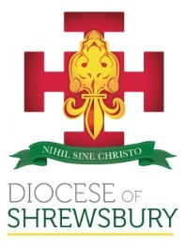
Diocese of Shrewsbury
Department of Education

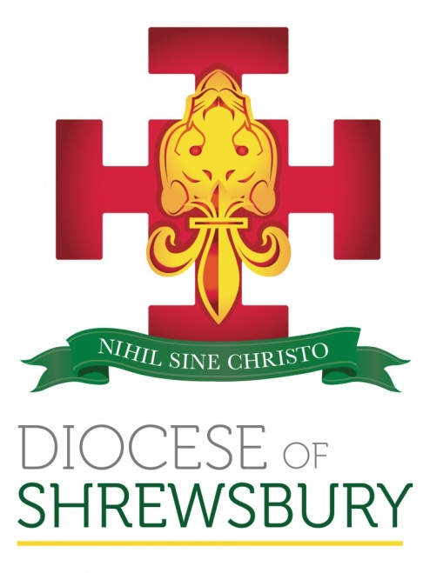

NEWSLETTER

Autumn Term 2020 No.2

DEPARTMENT FOR EDUCATION NEWSLETTER – AUTUMN 2020 No 2

Dear Colleagues
- INTRODUCTION
I hope all colleagues have had a restful half term and have managed to have some much-needed time with your families as we face yet another unprecedented half term. I hope, despite all the restrictions on school life at the moment, that as we approach the season of Advent and Christmas, we are able to mark these significant events in the Church’s year in a meaningful way.
- CHANGES OF HEADTEACHER
St Joseph’s Wallasey
Kathryn Vernon retired as Headteacher last week and we thank her for her years of service to the Diocese and wish her health and happiness in her retirement.
Maria Hollis takes over as Headteacher this week and we wish her every success in her new post.
Our Blessed Saints Federation
Stacey Beale, the Executive Headteacher of Our Blessed Saints Federation (St Luke’s, Trench and Ss Peter and Paul, Newport) has left the service of the Diocese to take up a new post and we wish her every success for the future.
Sarah Staniforth will be the Acting Headteacher at Ss Peter and Paul and Louise Evans the Acting Headteacher at St Luke’s. We express our thanks to both of them for providing interim leadership for these schools.
The following appointments to headship have been made this term:
Emily Cahill has been appointed substantive Headteacher of St Philip’s, Offerton with immediate effect.
Justine McEniff has been appointed substantive Headteacher of St Wilfrid’s, Hartford with immediate effect.
Lorraine Connolly has been appointed substantive Headteacher at Holy Spirit, Runcorn with immediate effect.
Catherine Ming has been appointed Headteacher at St Martin’s, Runcorn effective from 1st January 2021.
We continue to remember all our Headteachers in our prayers as they face the challenges of leading our schools in these unprecedented times.

- OFSTED
Ofsted continue with their Autumn visits this half term. We have had three schools who have had these visits and I have previously circulated feedback from visits and examples of schedules and questions. We have had our first published letter and it would seem from speaking to colleagues from the CES and other Dioceses that the letters are very similar and contain very little that is personalised to the school. It is still Ofsted’s intention to return to routine inspections in January 2021 and to lift the exemption on the inspection of schools previously graded Outstanding. I will continue to update you on these developments as and when we are informed of them
- CPDF PROGRAMME
For the foreseeable future all our training activities will remain virtual and although there was not a Headteacher briefing scheduled for this term I have included virtual briefings on Thursday 12th November (9.30 – 10.30am or 1.30 – 2.30pm).
Now that we have completed virtual training over the last half term, it would be helpful for both presenters and participants, if schools were able to provide a quiet space for participants, as well as a laptop with access to a microphone and a camera. Many thanks for your co-operation.
Please find below a full list of training events this half term, booking is via the Diocesan website:
http://www.dioceseofshrewsbury.org/education/courses/book-a-cpdf-course
4/11 New Headteachers’ Induction – Session 2
12/11 Headteacher Briefing (option of 2 sessions)
17/11 Primary Curriculum Working Party – Session 2
18/11 Primary Deputy & Assistant Headteacher Forum (option of 2 sessions)
19/11 COAST – Session 2
19/11 RE Co-ordinator Hub – Cheshire East (am)
19/11 RE Co-ordinator Hub – Wirral (pm)
20/11 RE Co-ordinator Hub – Stockport & Tameside (am)
20/11 RE Co-ordinator Hub – Manchester & Trafford (pm)
23/11 RE Co-ordinator Hub – Cheshire West & Chester (am)
23/11 RE Co-ordinator Hub – Warrington & Runcorn (pm)
24/11 NQT/RQT Induction, Primary Schools – Session 2
26/11 SHORE Meeting – Session 2
26/11 RE Co-ordinator Hub – Shropshire & Telford & Wrekin
27/11 Creative and Spiritual RE for 4-7s (Lat Blaylock) (option of 2 sessions)
30/11 Creative and Spiritual RE for 7-11s (Lat Blaylock) (option of 2 sessions)
8/12 Staff-led Collective Worship CPD session
- DENOMINATIONAL INSPECTION UPDATE
We are still awaiting an update from the CES regarding the DfE’s decision as to whether we can defer all Denominational Inspections until September 2021.
- GOVERNORS
If you would like us to list any Foundation Governor vacancies on our website, could you please contact Jake Murphy on jake.murphy@dioceseofshrewsbury.org
We are actively looking for Foundation Governors for a number of schools across the Diocese. If you are aware of anyone who meets the criteria and would like to become a Foundation Governor, could you ask them to speak to their Parish Priest and the relevant school.
We would remind schools to complete the Governors’ Code of Conduct Analysis attached at Appendix 1 and return it to Sue Blackwell on sue.blackwell@dioceseofshrewsbury.org (if you have not already done so).
- RSE (RELATIONSHIPS AND SEX EDUCATION)
Schools should by now have consulted with parents, governors and pupils and the RSE policy, if not already ratified, should be well on the way to being ratified. It is important that we get an overview of the teaching of sex education in our Primary schools, so please do complete the short online questionnaire. We would love to have a 100% return. You can find the questionnaire by following this link:

https://docs.google.com/forms/d/1ZYxM3oKBO2eLN9ysWZZXq4AbziHYHR9H-dhdMaNHevE/edit

Although there isn’t one recommended scheme of work to use for RSE, schools are reminded of the need to ensure that any schemes used are delivered through a Catholic lens and that lessons are founded on the teachings of the Catholic Church. There is a list of recommended resources listed in the FAQs document on the RSE Resources page of the website (Education/Information for Schools/RSE Resources). The password is: education
If you are using secular resources for teaching RSE, please ensure that they support our ethos. If you are not sure about the resources currently being used, please contact your Diocesan School Support Officer or julia.cunningham@dioceseofshrewsbury.org for advice.
- NORTH WEST CATHOLIC DIOCESES TRAINING PARTNERSHIP
Since March of this year the Directors of the Five North West Dioceses have been meeting together to review the current offer in relation to continuous professional development and formation of colleagues in our schools, and to plan a new programme that better meets the challenges of contemporary leadership in our Catholic schools.
In devising the programme on offer we have looked at three Core Courses
- Catholic Middle Leadership Programme
- Catholic Senior Leadership Programme
- Catholic Headship Programme
All these courses will be organised and facilitated by serving professionals and will show progression, allow participants the opportunity to relate their work in school to the knowledge they are acquiring, and consider aspects of management that may be different in the context of a Catholic school.
However, we recognise that developing as a leader is not just about following a specific programme, but that along the journey there needs to be the opportunity for formation as well as a responsibility to sustain those who are in the role. Therefore we will be offering a series of opportunities for all colleagues in our schools, not just those on leadership programmes, to deepen their understanding of the vocation of the Catholic teacher and how this translates in the wider context of the world we live.
Catholic Middle Leadership Programme
This had to be suspended in the Spring term, but the 2019 programme will now be extended into this academic year. The course will be reviewed during the academic year and the new revised programme will be launched and recruited to in the Summer Term 2021.
Catholic Senior Leadership Programme
This course has replaced the well established and respected Catholic Leadership programme and the first cohort was in 2019. Like the Catholic Middle Leadership Programme, it too has been suspended but will recommence this academic year, allowing the existing cohort to complete the programme. The programme will be re-launched and recruited to in the Summer Term 2021.
Catholic Headship Programme
This is a new programme specifically designed for those new to or seeking their first Headship. We had hoped to launch the programme in July of this year with a cohort beginning this September. We will now be launching the programme in Summer term 2021.
Other Events:
There will be throughout the year a series of events that will provide the opportunity to hear inspirational speakers, to evaluate your own career development and meet other aspiring and existing leaders across the Dioceses. Please follow the link below to the website, which will be updated as and when events are scheduled:
https://www.nwcdtp.org.uk/
- UPDATES FROM THE CES
Updated Disciplinary Policies
The updated disciplinary policies are now available to download from the CES website. The policies can be accessed by following the link below:
https://www.catholiceducation.org.uk/employment-documents/model-policies-and-procedures
Separate versions of the policies are available for schools in England and academies.
Schools should also ensure that they inform their HR provider if they adopt these policies.
In order to assist schools in understanding what changes have been made to the policies, I attach a document which outlines the changes that have been made (Appendix 2). In response to feedback, the policies are now provided in fully amendable word format which should make the documents easier to manage. We do not expect schools to make substantial changes to the policies without discussing this with the Diocese first.
- KEEPING CHILDREN SAFE IN EDUCATION 2020
A summary of the key changes in this document can be found at:
https://safeguarding.network/keeping-children-safe-education/#summary
- ADMISSIONS
Schools are reminded to complete and return the forms attached at Appendix 3 (primary) and Appendix 4 (secondary) (if you have not already done so) to Jake Murphy on jake.murphy@dioceseofshrewsbury.org . Please note that this information should include all children admitted into reception/Year 7, broken down into numbers for each of your over-subscription criteria, not just those over your PAN.
This term schools should be reviewing their Admissions Policy for 2022-23, and if they are intending to change their policy they must inform the Diocese and ensure that all stakeholders are part of the consultation. Further information, including consultation periods and deadlines, is attached at Appendix 5.
Please do not hesitate to contact Julie Johnson ( julie.johnson@dioceseofshrewsbury.org ) if you require any further information or guidance regarding admissions.
- USE OF SCHOOL E-MAILS
All members of school staff and governors are reminded that school e-mail addresses should not be used for personal e-mails.

Finally, I would like to thank all our colleagues working in schools for the tremendous job everyone is are doing in these challenging times and reassure you of the Diocese’s support and prayers in all that you do for the young people of our Diocese.

Damian

