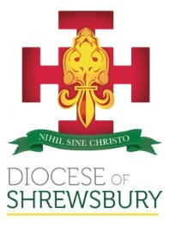
Diocese of Shrewsbury
Department of Education

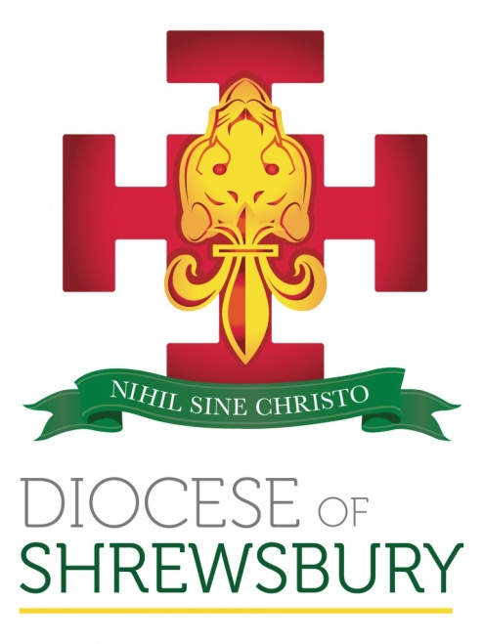

NEWSLETTER

Spring Term 2022 No.1

DEPARTMENT FOR EDUCATION NEWSLETTER – SPRING 2022 No 1

Dear Colleague

- INTRODUCTION

On Behalf of Bishop Mark and the Department Team may I wish the staff, governors and families of our Diocesan schools every good wish for 2022.

- APPOINTMENT AND CHANGES OF HEADTEACHER

Mrs Lisa Holland has taken up post as Headteacher at St Theresa’s in Chester with effect from 01/01/2022

Mrs Catherine Wright is the Acting Headteacher for St Mary’s, Crewe with effect from 01/01/2022

Mr John Daley will leave his position as Headteacher at St Gregory’s in Bollington at the end of January to take up a new position in the Liverpool Archdiocese and Mrs Jackie Walker will be the interim Executive Headteacher for the rest of this academic year.

We will keep all of them in our prayers as they take up their new positions.

- CPDF FOR THE SPRING TERM
In light of the current situation, and in conversation with representatives of DASH and DAPH, we have had to make some changes to the published CPDF schedule, with many of the planned ‘in person’ sessions now being offered virtually. Please see below the updated schedule for this term and take note of the new timings:
RE and Catholic life: a course for primary practitioners: this course has been postponed as it will not easily be transferrable to an online session. Delegates who have already signed up have been informed.
We hope to begin the course in the summer term but will review this after half term.
Prayer and Liturgy Twilight Sessions: Unfortunately, it will be necessary to postpone the next planned session (currently scheduled for 12th January). A delay to the release of the draft Prayer and Liturgy Directory has meant we have had to review the published dates.
Session One will now be a virtual session on Tuesday 8th February 4.00pm-5.30pm
Session Two will go ahead on 17th March as planned, though as a virtual event only.
New Headteacher Induction: It had been planned to look at the possibility of a residential for our new Headteachers, but this has now been postponed until the Summer Term. There will be a virtual session on Tuesday 18th January 1.00 p.m. – 4.00 p.m.

Induction session for new RE Coordinators (Thursday 20th January): this was scheduled to be a face-to-face meeting; however, this will now be a virtual session and an opportunity for staff new to the role of RE Coordinator since October to meet with other new RE Coordinators and find out more about this important role. The session will be slightly shorter and run from 1.30pm-3.30pm.
COAST: this was scheduled for 19th January at Loreto Grammar School in Altrincham. This meeting will now be online on 19th January from 9.30am – 12.00pm.
School support for inspection under the new CSI (Catholic Schools Inspectorate) framework scheduled for Friday 28th January: this will continue to be a face-to-face session to support schools who will be inspected under the new framework, especially those due to be inspected in 2022-23.
The RE Coordinator hub meetings will now run as half day virtual meetings:
Shropshire, Telford and Wrekin Hub 7th March, 9.30-12.00
Cheshire West and Chester Hub 9th March, 9.30-12.00
Cheshire East Hub 10th March, 9.30-12.00
Wirral Hub 18th March, 9.30-12.00
Runcorn and Warrington Hub 21st March, 9.30-12.00
Stockport and Tameside Hub 22nd March, 9.30-12.00
Manchester and Trafford Hub 23rd March, 9.30-12.00
Secondary DADAH and Secondary RSE Leads meetings were already scheduled to be virtual.
The SHORE meeting on 30th March will hopefully still run as a face-to-face meeting at St John Henry Newman Parish Centre in Latchford. This will be reviewed at half term.
To book onto any of the above courses please click on the link below:
https://www.dioceseofshrewsbury.org/education/courses/book-a-cpdf-course

NB: the virtual drop-ins will continue as scheduled.
RE Coordinators 26th January, 3.30-5.00
SHORE 27th January, 3.30-5.00

If you have any queries or questions regarding RE, assessment or any of the national developments you can log on at the above times to discuss them, though feel free to contact me via email or phone at any point: julia.cunningham@dioceseofshrewsbury.org Mob: 07715 521 902.

The revised Calendar for all CPDF courses this term can be found by following the link below:
CPDF Calendar - Spring 2022

- SUPPORT FOR ECTs
At the review of our CPDF provision with Headteachers last term it was identified that the original plan of not providing a specific Diocesan ECT programme because of the demands of the new national programme has resulted in ECTs in Diocesan schools losing an important means of support at the start of their career. As a consequence, we will look to offer a series of virtual twilight sessions for the rest of this academic year, with a more comprehensive programme planned for next academic year. Details of the ECT offer to schools will be published in the near future.
- CATHOLIC SCHOOLS INSPECTORATE
The new national framework for inspections of Catholic schools requires all inspectors to become members of the Catholic Schools Inspectorate (CSI).
Eligibility criteria to become an inspector includes:
- be a practising Catholic​
- be a qualified teacher
- either be one of the following in a school judged to be good or better under both statutory and denominational inspections:​
  - a current or recent holder of one of the three posts defined as a reserved post in the Bishops’ memorandum
  - a current assistant head teacher
- or be one of the following:
  - a current or recent holder of a relevant and equivalent high-level leadership or advisory position within education;
  - in exceptional circumstances, an experienced Catholic Schools inspector (or an inspector of an equivalent predecessor diocesan inspectorate) who has attended all mandatory training and has continued to be actively involved in Catholic education

If you are interested in finding out more about the role and how to apply to become an inspector, we are holding a briefing on Wednesday 19th January 10.00-12.00.
To indicate your interest and receive the Zoom link to join the briefing, please click on the link below:
Briefing on becoming an Inspector for the CSI, 19 January - booking form

- OFSTED

Ofsted issued in November revised guidance on the timing of inspections in order to address the backlog due to the pandemic. The full details can be found by following the link below:

Schedule for Inspection

Although the main implication of the increased funding is from September 2022 there are some implications for the rest of this academic year:

Good Schools
They intend to inspect all schools graded good in 2016/17 this academic year
Good schools receiving a ‘good improving’ judgement, or a ‘good declining’ judgement can expect a full section 5 around one year later.

Good schools that have previously had a ‘declining good’ judgement and are awaiting a full section 5 - we have received the following advice:
Inspections were suspended between March 2020 and Easter 2021, therefore the ‘inspection clock’ only restarted in May 2021. This means that the school’s Section 5 should take place between one to two years from this date. Added to this, Ofsted has made clear that inspections could be further delayed by up to 6 terms

Outstanding schools
Outstanding schools have been split into two groups:
Those inspected prior to September 2015 who will receive a full section 5 inspection and those inspected after September 2015 who will receive a section 8 inspection. These two groups will be inspected simultaneously starting with the oldest inspection judgement in each category.
A school that receives a ‘declining’ assessment in its section 8 will receive a full section 5 around a year later

Requires Improvement and Inadequate Schools
Prior to the pandemic schools could expect to be inspected within 30 months of their last inspection. This is expected to be delayed by between 5 & 6 terms, although as these schools have been a focus of inspection during the pandemic it could be sooner.

It must be noted that this was the position at the start of December. The latest information from Ofsted suggests that for á ‘temporary period’ they will not be asking school leaders who are Ofsted inspectors to partake in inspections and will “encourage early years settings, schools and colleges that are significantly impacted by COVID related staff absence to ask for their inspection to be deferred”.

- ADMISSIONS POLICIES

Admissions Policy 2023-24
Thank you to all those schools who have already sent their finally determined Admissions Policy 2023-24 to us.
All Governing Bodies must determine and ratify their Policy by 28th February, and publish it on the school’s website by 15th March. Even if there have been no changes to your admissions policy can you send a copy to the Admissions email (admissions@dioceseofshrewsbury.org) and ensure that it is sent to the Diocese and the LA no later than 31st March 2022.
In September we asked all schools to return details of their admissions for September 2021 for Reception and Year 7. Many thanks to all schools who have returned this information, but to date we still have 71 schools (over 63%) who have not returned the information. It is important that we are able to monitor admissions across the Diocese in order to look at future planning. I have created links to the returns: Primary Admissions or Secondary Admissions and would be grateful if those schools who have not as yet been able to send us the information could do so as a matter of urgency to malgorzata.kowalska@dioceseofshrewsbury.org
- DENOMINATIONAL INSPECTIONS

For those schools who are being inspected this year under the current framework, support is available on request from your school support officer in the first instance, and carol.morgan@dioceseofshrewsbury.org (Denominational Inspection Coordinator for Primary) and julia.cunningham@dioceseofshrewsbury.org (Denominational Inspector for Secondary).
NB: the recording of the briefing held in June 2021 is available upon request
http://www.dioceseofshrewsbury.org/education/recordings
In light of current guidance from the DfE, in the same way that Ofsted will consider a deferral of an inspection due to significant staff absence as a consequence of Covid, the Diocese will also consider such requests for the same period of time.

- UPDATES FROM CES

CES Census January 2022

The CES census 2022 will start on 20th January in England and the CES have sent a letter to all schools at the end of last term as well as a FAQs document,
However there is in addition further support on the census website: http://cescensus.org.uk/helpdesk/. There is a helpdesk telephone number if schools have a problem accessing the online helpdesk: 020 7901 1909. We strongly advise schools to use the online helpdesk as it is more efficient and is monitored outside normal hours during the busiest period. The letter has a list of numbers for schools to call in each Diocese.
Resources for schools from the Information Commissioner’s Office
The Information Commissioner’s Office has created a suite of resources for teachers to use with students looking at data protection , social media and privacy issues which may be of use for a PSHE/Key Skills/Tutor time session:
https://ico.org.uk/for-organisations/posters-stickers-and-e-learning/school-resources/
The materials are for primary and secondary age children and they include slides for use in lessons and worksheets.
- GOVERNOR APPOINTMENTS

As we start the new term can I remind schools and academies that although we welcome nominations for Foundation Governors from schools and Governing Bodies, it is the Bishop that makes the final decision and therefore potential Governors should not assume they have been made a Foundation Governor until they have received notification of their term of office in writing. Particular care needs to be taken if you are considering transferring a Governor from a previous status (e.g. Parent to a Foundation Governor). They must be formally appointed to the position of Foundation Governor.

Governors are reminded that in 2017, the Diocese placed a restriction on family members being Governors on the same Governing Body. If a Governing Body does have members of the same family, then this should be considered at the end of the Term of Office. This now appears in the Diocese’s List of Disqualification.

- CHANGE OF SCHOOL TELEPHONE NUMBERS

We are aware that the following schools have changed their contact telephone numbers recently:

St Mary’s, Crewe 01270 260620
St Mary’s, Middlewich 01606 516171

We would be grateful if any other schools that have recently changed their telephone number could advise us on sue.jenkinson@dioceseofshrewsbury.org

I wish you and all your staff every blessing for the New Year.
Damian

